25 March 2025

ACCEPTANCE LETTER

Client: City of Tshwane

BID NO: SS 02 – 2023/24

Dear Sir/Madam

On behalf of SITHEMBE TRANSPORTATION AND PROJECTS, I hereby accept the appointment letter dated 12 March 2025, for the tender: TENDER FOR THE CORPORATE HIRE OF GENERAL CONSTRUCTION MACHINES AND CONSTRUCTION EQUIPMENT: AS AND WHEN REQUIRED: THREE (3) YEAR PERIOD: WITH EFFECT FROM 01 APRIL 2025 OR NEAREST DATE.

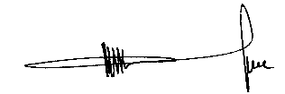
……………………………………………
MR. M.V LUKHELE
Director

